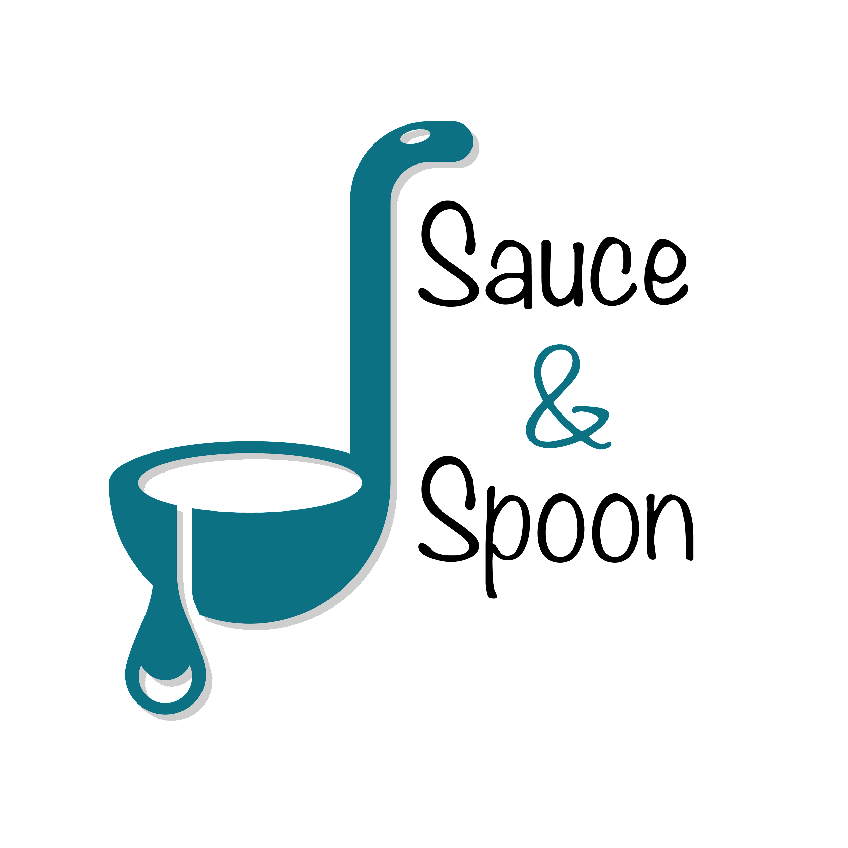

Project Charter: Tabletop Menu Tablets

DATE: [10/07/24]

|  |
| --- |
| **Project Summary** |
| We are launching a pilot rollout of tabletop tablets with menus at two Sauce & Spoon establishments - north and downtown. The goal of this initiative is to enable guests to order as soon as they arrive, speed up service, reduce table service times and increase daily guest counts. This will provide clear data to track metrics, help reduce food waste by directly communicating guest requests to the kitchen, and ultimately contribute to the success of the restaurant. |

|  |
| --- |
| **Project Goals** |
| * Raise the average check total from 65$ to 75$ by increasing product mix and   increasing the number of appetizers ordered by 15%   * Ensure sufficient staffing at both entry and exit points to handle a 10% increase in daily guest counts. * Decrease average table turn time by approximately 30 minutes by EOY. * Decrease customer checkout time by 10% within the first six weeks after implementation. * Achieve 95% customer satisfaction in the pilot phase. * Maintain <5% technical issues reported by customers within the first six months. |

|  |
| --- |
| **Deliverables** |
| * Increase appetizer orders by 15% overall, with a 10% target at the North location and a 20% target at the Downtown location. * Decrease average table turn time by 30 minutes. * Boost the average check total to $75 by promoting more appetizers and beverages, leading to higher profits. * Increase the average daily guest count by 10%.Implement a comprehensive staff training plan. * Enhance communication of guest requests to the kitchen, reducing comped meals and food waste by 25%. * Ensure seamless integration with the existing POS system. |

|  |
| --- |
| **Scope and Exclusion** |
| **In-Scope:**   * Food waste reduction and order return rate * Raising check total * Decreasing table turn time Increasing average daily guest count * Staff training * System integration with the existing POS system * Tablet implementation * Hiring additional staff * Marketing promotion * Post-dining survey implementation   **Out-of-Scope:**   * Policy changes |

|  |
| --- |
| **Benefits & Costs** |
| **Benefits:**   * Provide clear data points on customer ordering * Improve service times and order accuracy, leading to increased customer satisfaction. * Increase the number of guests served and total revenue. * Reduce food waste and operational inefficiencies. * Enhance employee satisfaction.   **Costs:**   * Training materials and fees: $10,000 * Hardware and software implementation: $30,000 * IT maintenance: $5,000 * Update website and menu design updates: $5,000 * Customization: $ 550 |

|  |
| --- |
| **Appendix:** |
| * **Misalignment**: There was a difference of opinion on increasing appetizer sales. One viewpoint was that suggesting more appetizers wouldn't significantly impact sales, while another proposed a 20% increase in appetizer orders. **Decision**: Implement a 15% average increase overall, with a 10% increase targeted for North location and a 20% increase for South location. * **Misalignment**: There was debate about including policy changes related to order returns in the project charter. **Decision**: Policy changes on order returns will be handled separately from the tablet project and discussed as an operations item. * **Misalignment**: There was disagreement on whether measuring employee satisfaction should be part of the project scope. **Decision**: The approach to measuring employee satisfaction will be developed separately. * **Misalignment**: Food waste is a major reason for the need to revise food return policies  **Decision**: Food waste is part of the problem, but also kitchen staff perform poorly during busy periods combined with food returns. The food waste target will be adjusted to better reflect the performance of the kitchen staff. |